Supplemental Materials for

**Graph neural networks enable design of high-performance aluminum alloys for laser powder bed fusion**

Jiabo Fua, Xingming Yanga, Hongyuan Zhangb,c,d, Xinni Tianb,c,d, Hao Yua,*, Chenchong Wanga, Wei Xua

*a State Key Laboratory of Digital Steel, Northeastern University, Shenyang 110819, China*

*b Department of Materials Science and Engineering, Monash University, VIC 3800, Australia*

*c Monash Centre of Additive Manufacturing, Notting Hill, VIC 3168, Australia*

*d Suzhou Industrial Park Monash Research Institute of Science and Technology, Suzhou, China*

Corresponding Author E-mail address: [yuhao@ral.neu.edu.cn](mailto:yuhao@ral.neu.edu.cn)

This file includes:

Supplementary 1 to 7

Table S1 to S6

Figs. S1 to S9

**Supplementary 1: The description of simulation for thermal history during additive manufacturing based on finite element method**

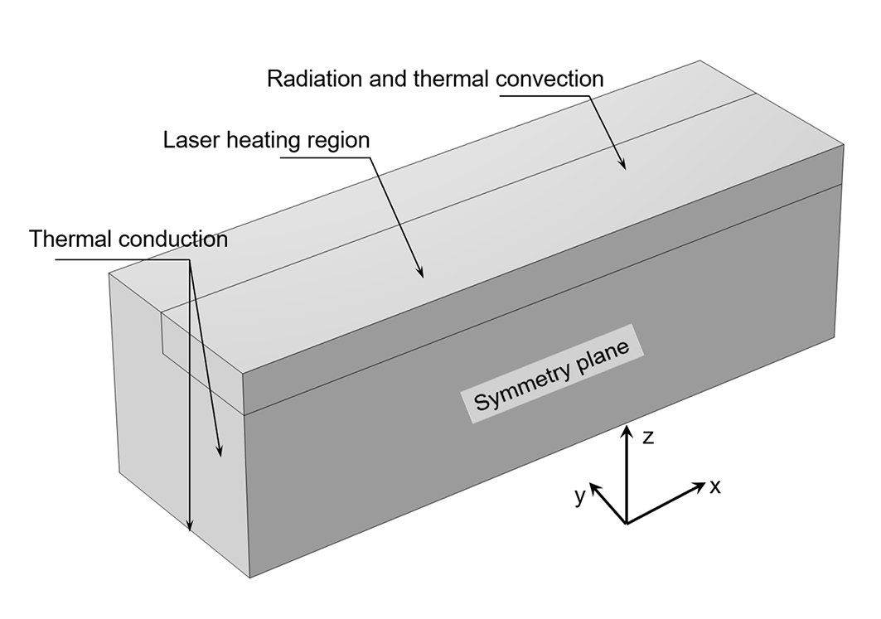

Fig. S1. The computational domain and boundary conditions.

To better understand the impact of physical metallurgical conditions on the microstructure of Al alloys, the thermal history and solidification behavior during the Laser Powder Bed Fusion (LPBF) single-track printing process were simulated using the finite element method. Mechanistic variables influencing cracking were calculated based on a transient three-dimensional heat transfer and fluid flow model[1-4]. Several reasonable assumptions are made as follows[5-9]: (1) Liquid metal flow within the molten pool is considered Newtonian, laminar, and incompressible. (2) Vaporization is neglected due to the system's calculated peak temperature being below the material's boiling point. (3) The mushy zone, where temperatures range between the solidus and liquidus, is modeled using a porous medium with isotropic permeability. (4) The influence of shielding gas is disregarded due to its minimal pressure. (5) Powder instantaneously melts upon contact with the deposition surface and is treated as a continuous and uniform phase.

**Governing equation**

The heat transfer energy equation in all domains is defined as (1):

|  |  |  |
| --- | --- | --- |
|  | $$ρC_{p}\left(\frac{∂T}{∂t}+u⋅∇T\right)=-∇⋅q+Q$$ | (1) |

where, $ρ$ is the density, $C_{p}$ is the specific heat capacity, $T$ is the temperature, $t$ is the time, $u$ is the speed, $q$ is the heat flux and given by the Fourier’s conduction equation, as shown in Eq. (2), $Q$ is the heat rate per unit of volume, as defined as Eq. (5).

|  |  |  |
| --- | --- | --- |
|  | $$q=-k∇T$$ | (2) |

where, $k$ is the thermal conductivity.

Velocities of the metal inside the molten pool are regarded as incompressible fluids and can be calculated by solving the following Navier-Stokes Eq. (3) and the continuity Eq. (4).

|  |  |  |
| --- | --- | --- |
|  | $$ρ\left(u_{,t}+u∙∇u-g\right)+∇p-2μ∆u=0$$ | (3) |

|  |  |  |
| --- | --- | --- |
|  |  | (4) |

Where $u$ is the velocity field, $p$ is the pressure field, $g$ is the gravity acceleration vector, ∇ is the gradient operator, ∆ is the Laplace operator, $ρ$ and $μ$ are density and dynamic viscosity, respectively.

**Initial and boundary conditions**

The substrate and cladding are assumed to be initially at the ambient temperature $T_{0}$ and pressure $P_{0}$, and at a zero initial velocity field. The heat flux at the interface is defined as:

|  |  |  |
| --- | --- | --- |
|  | $$Q=\frac{2Pη_{l}}{πr_{b}^{2}}\exp{(}\frac{-2((x-vt)^{2}+y^{2})}{r_{b}^{2}})-h_{c}\left(T-T_{0}\right)-σ_{b}η\left(T^{4}-T_{0}^{4}\right)$$ | (5) |

The right of Eq. (5) represents the laser heat flux, thermal convection and radiation, respectively. Where $P$ is the laser power, $η_{l}$ is the absorption of laser energy, $x$ and $y$ are the distance to the laser, $r_{b}$ is the effective laser beam radius, $v$ is the scanning speed, $h_{c}$ is the heat transfer coefficient, $σ_{b}$ is the Stefan-Boltzmann constant, $η$ is the emissivity.

The computational domain and boundary conditions are illustrated in Fig. S1. The laser heat source is positioned on the top surface of the cladding. Radiation and convection heat transfer are applied to the upper surface of both the substrate and the cladding layer. Heat conduction within the metal is considered for the surrounding areas and the bottom of the substrate. Additionally, a fixed constraint is applied at the bottom. The computational domain includes a substrate with the dimensions of 5mm×10mm×5mm and a single track with the length of 10mm. The maximum time step is 1×10-2 s. Simulations were performed on a ROG computing station (64×2.30GHz-128GB).

**Calculation of solidification mechanistic parameters**

The dendritic morphology during laser cladding is subsequently influenced by these parameters through their modulation of ​​solidification conditions​​, particularly the temperature gradient ($G$), perpendicular to the solidification front. The model presented in this paper is based on the Cartesian coordinate system, and *G* is expressed as:

|  |  |  |
| --- | --- | --- |
|  | $$G=\left(\frac{∂T}{∂x},\frac{∂T}{∂y},\frac{∂T}{∂z}\right)$$ | (6) |

Solidification growth rate $R$ is another solidification parameter which is normal to the solid/liquid interface and its magnitude can be expressed as[4]:

|  |  |  |
| --- | --- | --- |
|  | $$R=v_{s}∙\frac{\frac{∂T}{∂x}}{G}$$ | (7) |

The solidification parameter $G∙R$ is related to the grain size, representing the instantaneous cooling rate on the solidification front. The ratio of $G/R$ is the solidification parameter $ε$, which has important relevance to the microstructural morphology[1-3].

Table S1. Process parameters used in this study.

|  |  |
| --- | --- |
| Parameters | Value |
| Laser power, W | 100-370 |
| Scanning speed, mm/s | 98-3000 |
| Absorptivity | 0.7 |
| Layer thickness, mm | 20-60 |
| Laser beam radius, mm | 70-100 |
| Angular frequency of the laser, rad/s | 1.75×1015 |
| Permittivity, F/m | 8.85×10-12 |

Table S2. Material properties of partial alloys used in dataset.

|  |  |  |  |  |
| --- | --- | --- | --- | --- |
| Parameter | AlSi10Mg | AlMgScZr | Al6061 | AA2024 |
| Solidus temperature, K | 847 | 723 | 805 | 780 |
| Liquidus temperature, K | 852 | 1132 | 919 | 904 |
| Density, kg/m3 | 2650 | 2971 | 2714 | 2800 |
| Thermal conductivity, W/(m•K) | 113 | 137.9 | 137.9 | 137.9 |
| Specific heat capacity, J/(kg•K) | 876 | 937 | 893 | 873 |
| Latent heat of fusion, kJ/kg | 496 | 313 | 409 | 358 |
| Dynamic viscosity, Pa•s | 1.3×10-3 | 1.5×10-3 | 1.5×10-3 | 1.3×10-3 |
| Surface tension, N/m | -0.35×10-3 | -0.40×10-3 | -0.40×10-3 | -0.35×10-3 |

Here, T represents temperature in K. Density is taken at room temperature, latent heat of fusion at the solidus temperature, and dynamic viscosity at the liquidus temperature. The temperature dependence of density, thermal conductivity, specific heat capacity, dynamic viscosity and surface tension are calculated using Thermo-Calc software and TCAL 6 database.

**Supplementary 2: Mean decrease accuracy (MDA) results for composition & process condition features and inclusions in the dataset used**

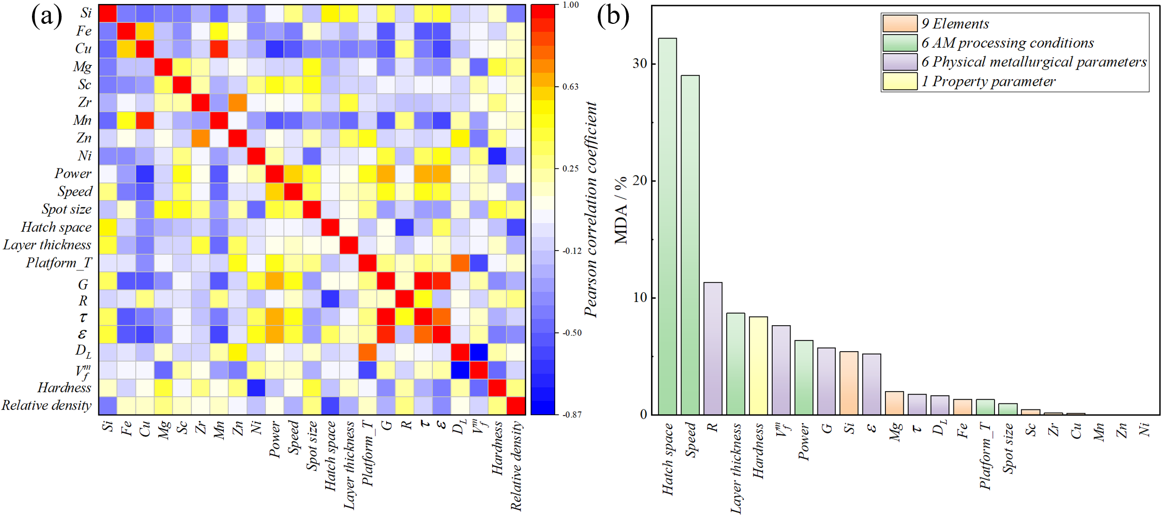

Fig. S2. (a) Pearson correlation coefficient and (b) MDA results of features in the dataset used.

**Supplementary 3: The architectural settings and prediction of the introduced physical metallurgical parameters and hardness property**

Graph Attention Networks (GATs) were adopted for their computational efficiency in processing graph-structured data [10,11], with their integration with physical-metallurgy-knowledge-informed graphs further enhancing prediction accuracy, interpretability, and generalization, particularly in data-limited scenarios [12]. The framework employs a knowledge-informed graph $G=(V,E)$ to convolve input features, where nodes $V$ represent variables and edges $E⊆V×V$ denote directional relationships. Specifically, edge $(j,i)∈E$ indicates the influence of node $j$ on node $i$, with each node $i$ initialized as $h_{i}^{(0)}∈R^{d_{0}}$. The model initially assumes equal importance among neighboring nodes.

In the input layer, node representations $\{{\vec{h}}_{i}|i∈V\}$ and edge set $E$ are processed to update node representations ${\vec{h}}_{i}^{'}$ via Eq. (8). The attention mechanism then computes a weighted average of neighbor nodes $j∈N_{i}$: the edge score $e∈R^{d}×R^{d}→R$ is derived from the scoring function (Eq. (9)), followed by SoftMax normalization (Eq. (10)) to obtain attention coefficients. The weighted neighbor features (passed through nonlinearity σ) are aggregated per Eq. (11) to generate the updated node representation .

|  |  |  |
| --- | --- | --- |
|  |  | (8) |

|  |  |  |
| --- | --- | --- |
|  |  | (9) |

|  |  |  |
| --- | --- | --- |
|  |  | (10) |

|  |  |  |
| --- | --- | --- |
|  |  | (11) |

Finally, a multiple attention mechanism is used to enhance the stability of the model. The results of $K$ independent attention mechanisms are averaged by EQ. (12) to obtain the final output feature representation, which is then passed through the fully connected layer to obtain the defect prediction results [10].

|  |  |  |
| --- | --- | --- |
|  | $${\vec{h}}_{i}^{'}=σ\left(\frac{1}{K}\sum_{k=1}^{K}{\sum_{j∈N_{i}}{α_{ij}Wh_{j}}}\right)$$ | (12) |

In this study, the knowledge graph construction follows specific connectivity rules. As shown in Fig. S3, all composition nodes and select process nodes establish directional edges toward physical metallurgy information nodes and hardness nodes (weighted as ‘1’), while physical metallurgy information nodes exclusively connect to hardness nodes (also weighted as ‘1’). All other node connections are assigned a weight of ‘0’.

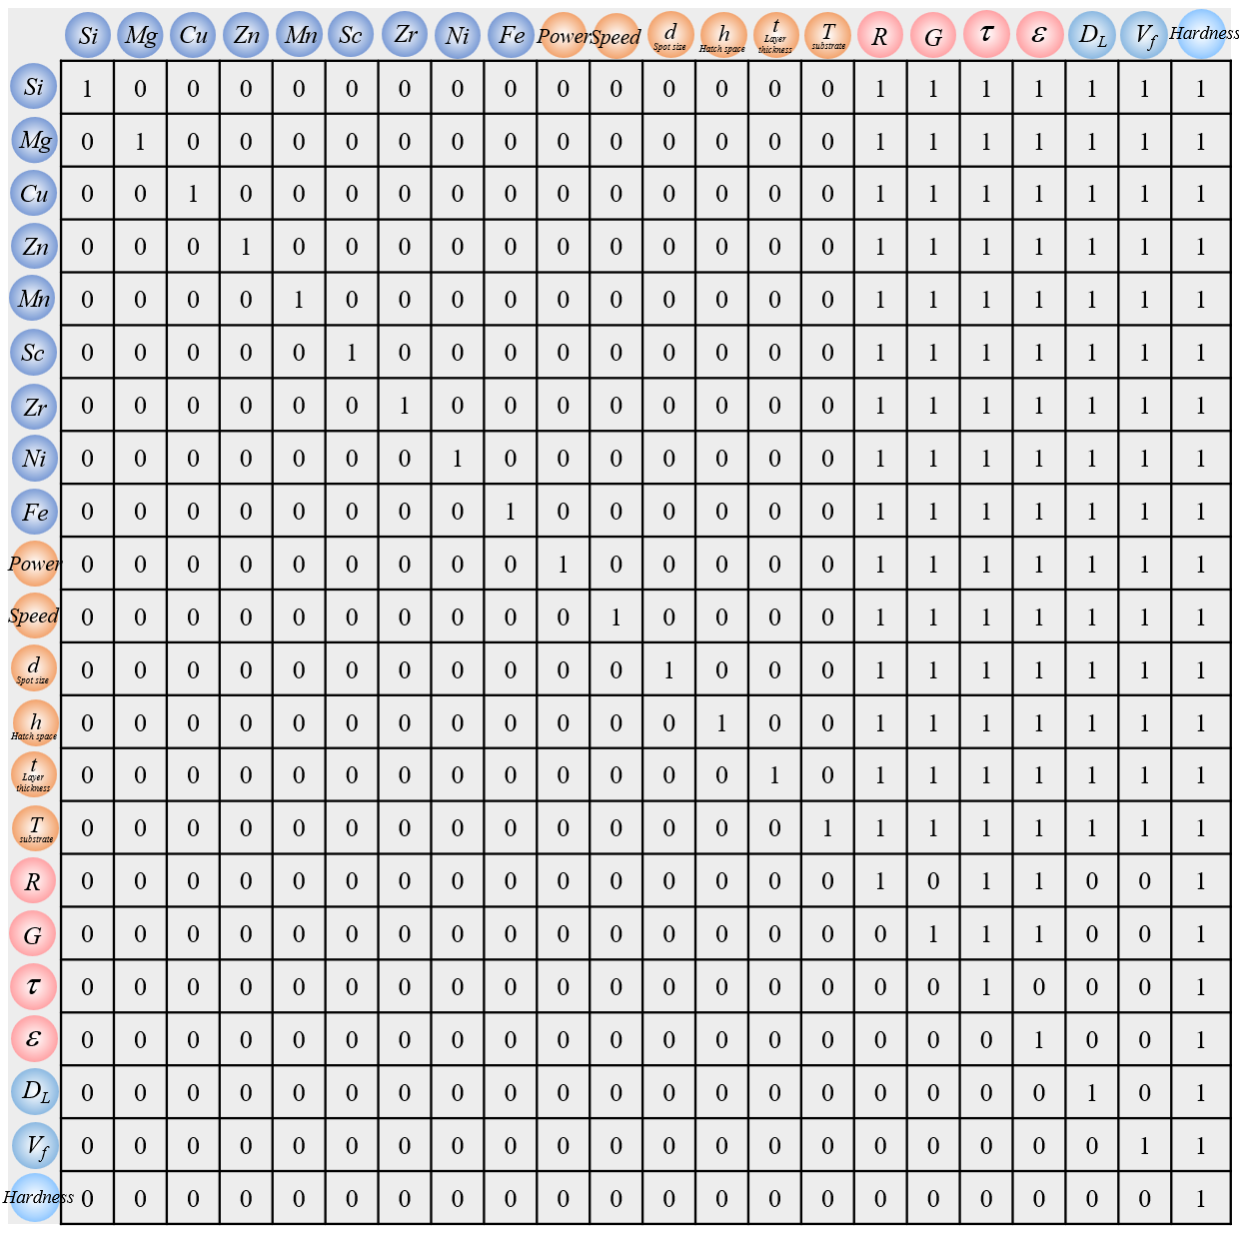

Fig. S3. The adjacency matrix of constructed physical-metallurgy knowledge graph.

Table S3. The PM-KGAT architecture details.

|  |  |
| --- | --- |
| Layer(type) | Shape |
| GraphAttentionLayer (graph_modules) | 22 |
| flatten_1 (Flatten) | 132 |
| dense_1 (Dense) | 400 |
| relu_1 (Relu) | 400 |
| dropout_1 (Dropout) | 400 |
| dense_2 (Dense) | 20 |
| dense_2 (Gelu) | 20 |
| dense_4 (Dense) | 2 |

For the reverse design process of alloy compositions and processing parameters, integrating the PM-KGAT model with the genetic algorithm is crucial. Prior to designing alloys, it is essential to establish quantitative correlations between composition-process and thermodynamic variables, solidification mechanistic variables, as well as between composition-process, thermodynamic variables, solidification mechanistic variables, and the hardness property, using machine learning algorithms. These characteristics reflect the mathematical and physical relationships between composition-process and physical metallurgical variables. As a result, features identified through these computational and simulation methods are often of high quality. In this study, a convolutional neural network algorithm was employed to establish the relationship between input and output features. The applicability of CNN has been verified in other studies[13,14], where CNN has demonstrated superior performance compared to traditional neural networks. The optimal model prediction results for solidification mechanistic variables and thermodynamic variables are shown in Figs. S4(a-d). The results indicate that the CNN model's R² values for both the training set and test set exceed 95%, and it also achieves a low mean absolute error (MAE). Thus, the quantitative correlation between composition-process and physical metallurgical variables established using the CNN model has high predictive accuracy and excellent generalization ability.

Similarly, a quantitative correlation between composition, process, physical metallurgical variables, and property variables was established using the CNN model. The parameters of the convolutional neural network were set as follows: the first convolutional layer is 5×5×8, the second convolutional layer is 5×5×16, the fully connected layer is 1×1×400/1×1×200/1×1×20, and the filter size is 3×3. For CNN training, the model was obtained after 1600 iterations, using a mean-squared error loss function, a learning rate of 0.001, and the Adam optimizer. The prediction results of the optimal model under 20 random divisions are shown in Fig. S3(e), with the high R² value on the test set is 90.3% and an MAE of 5.7 HV.

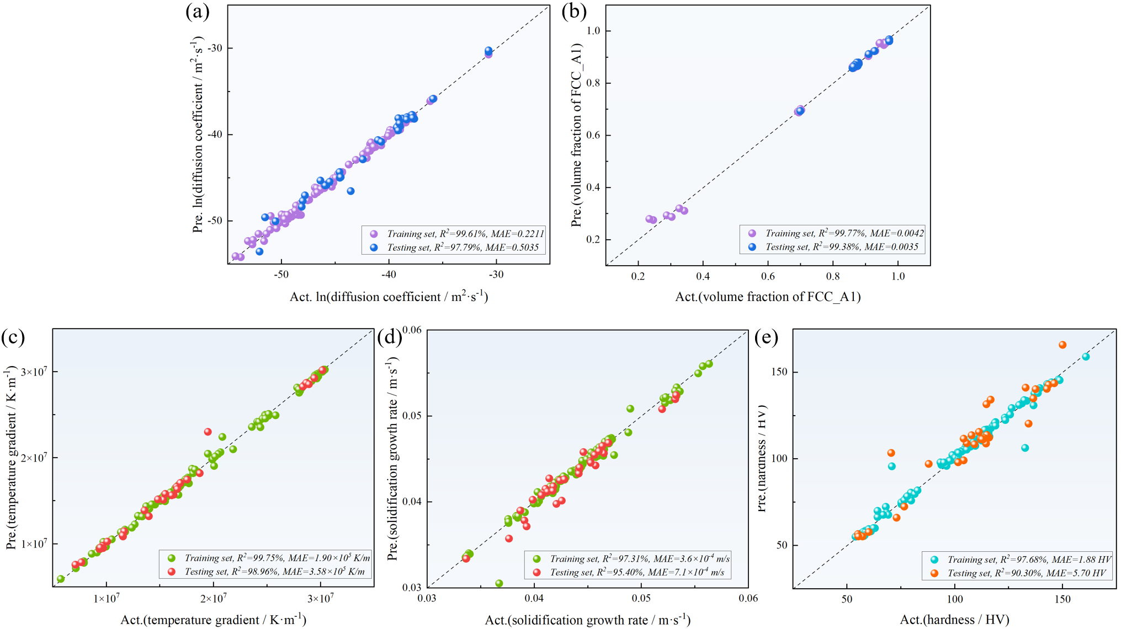

Fig. S4. The prediction results of the (a-d) introduced physical metallurgical parameters and the (e) hardness property.

**Supplementary 4: The microstructural features of the LPBF-ed KG-AMAA alloy**

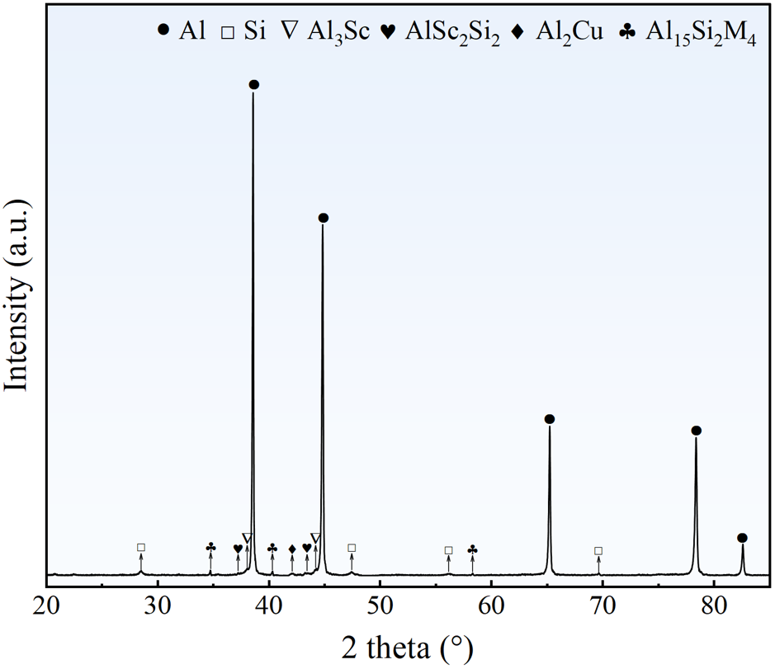

Fig. S5. X-ray Diffraction patterns of the as-printed samples of KG-AMAA alloy along the building direction.

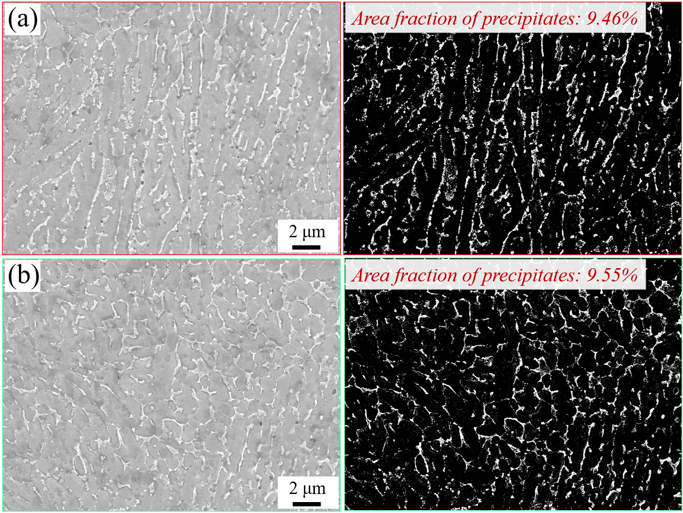

Fig. S6. The SEM images of chemically etched samples illustrating the microstructural features, accompanied by quantitative analysis results showing the total area fraction of precipitates.

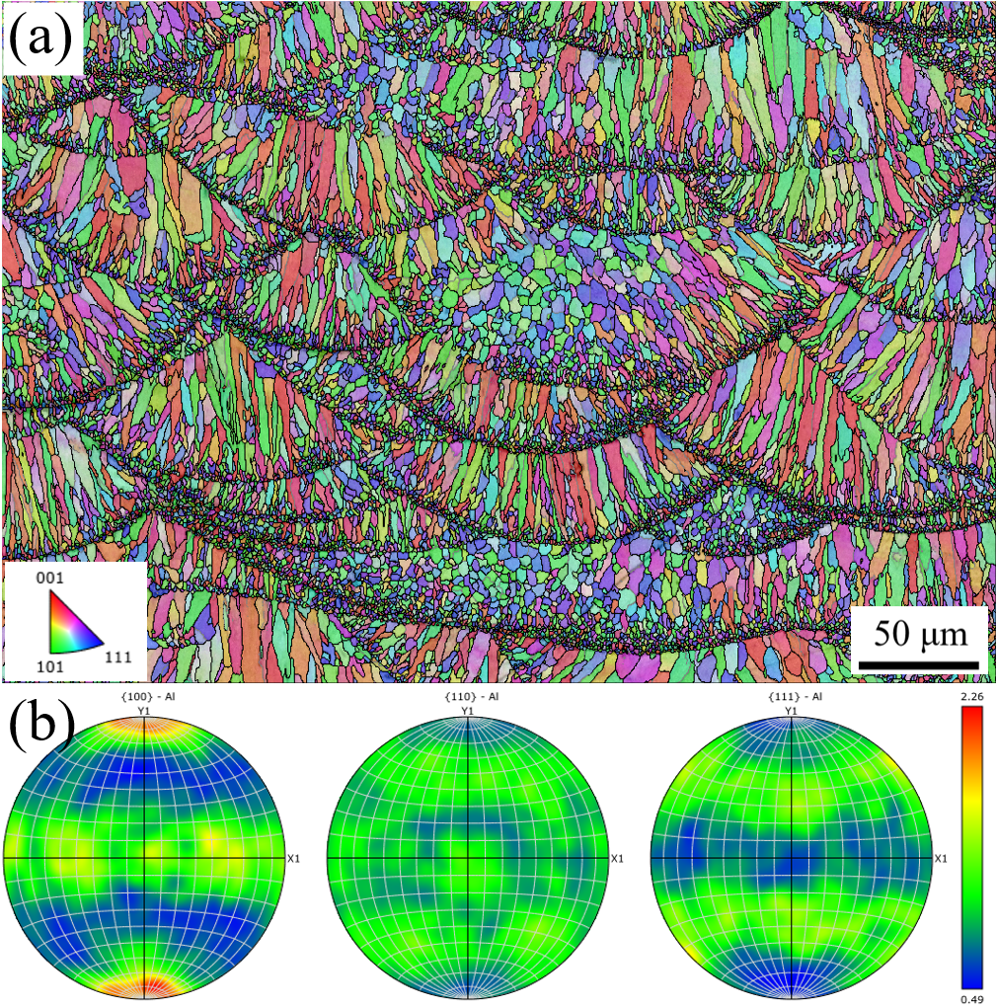

Fig. S7. The (a) IPF map, BC map overlapped with grain boundary plots showing the grain morphology histograms, and (b) pole figure of as-printed KG-AMAA alloy.

**Supplementary 5: Compositions of analyzed commercial Al alloys and AM-ed Al alloys**

Table S4. Compositions of analyzed commercial Al alloys and AM-ed Al alloys (in wt.%).

|  |  |  |  |  |  |  |  |  |  |  |
| --- | --- | --- | --- | --- | --- | --- | --- | --- | --- | --- |
|  | **Si** | **Fe** | **Cu** | **Mg** | **Sc** | **Zr** | **Mn** | **Zn** | **Ni** | **Al** |
| **AA2024[15]** | 0.72 | 0.11 | 3.84 | 1.27 | 0 | 0 | 0.36 | 0.01 | 0 | Bal. |
| **AA2024[16]** | 0.5 | 0.5 | 4.9 | 1.8 | 0 | 0 | 0.9 | 0 | 0 | Bal. |
| **AA2011[17]** | 0.4 | 0.72 | 5.6 | 0 | 0 | 0 | 0.05 | 0.3 | 0.02 | Bal. |
| **AA2014[18]** | 0.8 | 0 | 4.4 | 0.5 | 0 | 0 | 0.6 | 0 | 0 | Bal. |
| **ER2319[19]** | 0.106 | 0.156 | 5.95 | 0.009 | 0 | 0.104 | 0.273 | 0.012 | 0 | Bal. |
| **AA5052[20]** | 0.1 | 0.3 | 0.01 | 2.4 | 0 | 0 | 0.04 | 0.03 | 0.1 | Bal. |
| **AA5083[21]** | 0.08 | 0.16 | 0.031 | 4.365 | 0 | 0 | 0.5 | 0.002 | 0.08 | Bal. |
| **AA5754[22]** | 0.06 | 0.19 | 0 | 3.08 | 0 | 0 | 0.26 | 0 | 0.06 | Bal. |
| **AA5005[23]** | 0.15 | 0.3 | 0 | 0.85 | 0 | 0 | 0 | 0 | 0.15 | Bal. |
| **AA6061[24]** | 0.78 | 0.28 | 0.21 | 1.14 | 0 | 0 | 0.09 | 0.06 | 0.1 | Bal. |
| **AA6063[25]** | 0.51 | 0.16 | 0.06 | 0.71 | 0 | 0 | 0 | 0 | 0.12 | Bal. |
| **AA6082[26]** | 1.11 | 0.2 | 0.002 | 0.61 | 0 | 0.13 | 0.51 | 0 | 0 | Bal. |
| **AA6005[27]** | 0.6 | 0.22 | 0.13 | 0.59 | 0 | 0 | 0.09 | 0 | 0 | Bal. |
| **AA7075[28]** | 0 | 0.15 | 1.26 | 2.23 | 0 | 0 | 0.02 | 5.61 | 0 | Bal. |
| **AA7050[28]** | 0 | 0.08 | 1.82 | 1.92 | 0 | 0 | 0.01 | 5.65 | 0 | Bal. |
| **Al12Si[29]** | 11.8 | 0.17 | 0 | 0 | 0 | 0 | 0 | 0 | 0 | Bal. |
| **AlSi10Mg[30]** | 9.83 | 0 | 0 | 1.19 | 0 | 0 | 0 | 0 | 0 | Bal. |
| **AlMgScZr[31]** | 0.04 | 0.15 | 0 | 14.6 | 0.35 | 0.21 | 0 | 0 | 0 | Bal. |
| **AlMgScZr[32]** | 0.14 | 0.08 | 0.44 | 3.4 | 1.08 | 0.23 | 0 | 0.07 | 0 | Bal. |
| **AlMgScZr[33]** | 0.14 | 0.08 | 0.44 | 3.4 | 1.08 | 0 | 0.5 | 0.23 | 0 | Bal. |
| **AlMgZnSi[34]** | 1.96 | 0.17 | 0 | 5.39 | 0 | 0 | 0.75 | 3.08 | 0 | Bal. |
| **Al7075-Zr[35]** | 2.9 | 0.5 | 1.47 | 1.9 | 0 | 1 | 0 | 5.1 | 0 | Bal. |
| **AlZnMgSiScZr[36]** | 3 | 0 | 0 | 2.2 | 0.4 | 0.2 | 0 | 6.5 | 0 | Bal. |
| **AlMgNiScZr[37]** | 0 | 0 | 0 | 2.5 | 0.4 | 0.1 | 0 | 0 | 1 | Bal. |

**Supplementary 6: Solid solution strengthening coefficients used in this study**

Table S5. Solid solution strengthening coefficient for alloying elements (MPa per at.%1/2) [38,39]

|  |  |  |  |  |
| --- | --- | --- | --- | --- |
|  | Cu | Mg | Mn | Zn |
| $$k_{i}$$ | 60 | 20.5 | 80 | 3.1 |

**Supplementary 7: The role of metallurgical knowledge in reducing overfitting vs. pure data-driven GAT**

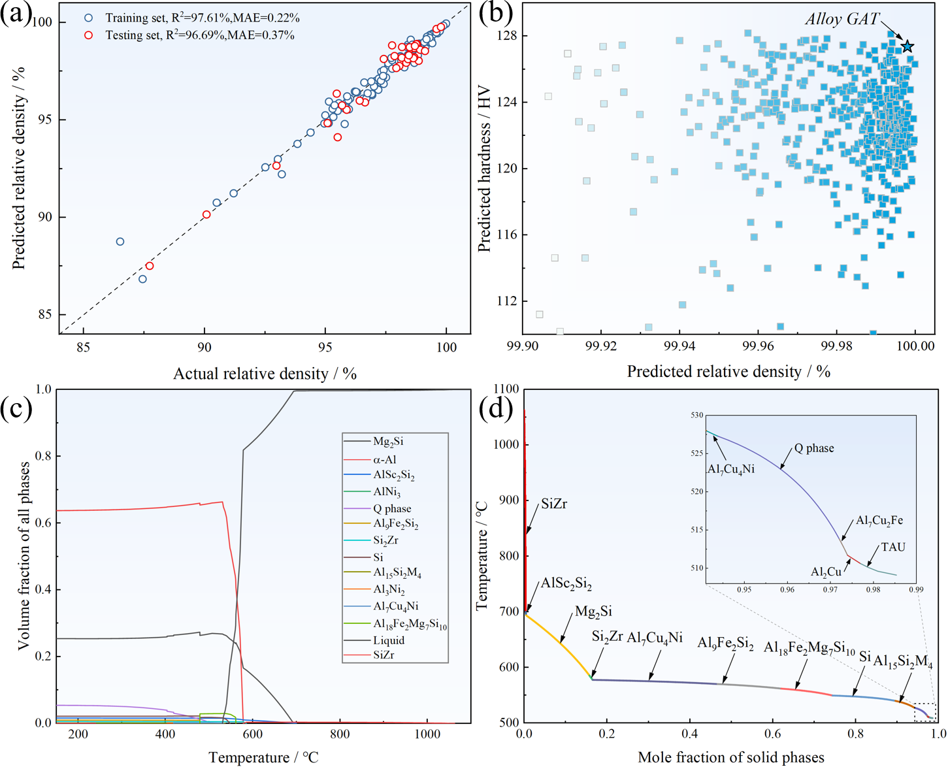

Fig. S8. (a) Prediction results of relative density via pure data-driven GAT model, (b) design results of relative density and quantified hardness, (c) The calculated phase configurations and (d) Scheil-Gulliver solidification curve.

The pure data-driven GAT model, which completely disregards physical-metallurgical constraints and treats all composition-process nodes as isolated entities, achieved an R2 of 96.69% on the testing set (outperforming our knowledge-guided GAT model's 95.21%) with a marginally lower MAE of 0.37%, as shown in Fig. S8(a). However, upon implementing inverse design using this purely data-driven approach (Fig. S8(b)), we obtained a composition with seemingly optimal properties (relative density: 99.999%, hardness: 127.4 HV; Table S6) but featuring critically unbalanced elemental concentrations: Si (12.05 wt.%), Mg (14.48 wt.%), and Sc (1.08 wt.%) all approaching their respective dataset upper limits - a clear manifestation of overfitting to extreme data points. This is further corroborated by phase composition analysis (Figs. S8(c) and (d)), which revealed an implausible microstructure comprising 12 distinct precipitate phases (including multiple metastable phases) with excessive precipitation fraction, coupled with an alarmingly high crack susceptibility index of 2345.4K that predicts severe hot-cracking risks during LPBF. Collectively, these findings provide compelling evidence that incorporating physical-metallurgical knowledge into the knowledge graph framework serves as an effective regularization mechanism: it not only constrains the model's solution space to physically plausible regions but also prevents overfitting to outlier data, thereby ensuring the generation of alloy designs that are both optimized for printability and grounded in fundamental material science principles.

Table S6. The alloy compositions of new alloy designed by pure data-driven GAT (in wt.%).

|  |  |  |  |  |  |  |  |  |  |  |
| --- | --- | --- | --- | --- | --- | --- | --- | --- | --- | --- |
|  | **Si** | **Cu** | **Sc** | **Zn** | **Mg** | **Ni** | **Fe** | **Mn** | **Zr** | **Al** |
| **GAT** | 12.05 | 1.21 | 1.08 | 0.03 | 14.48 | 0.05 | 0.36 | 0.05 | 0.62 | Bal. |

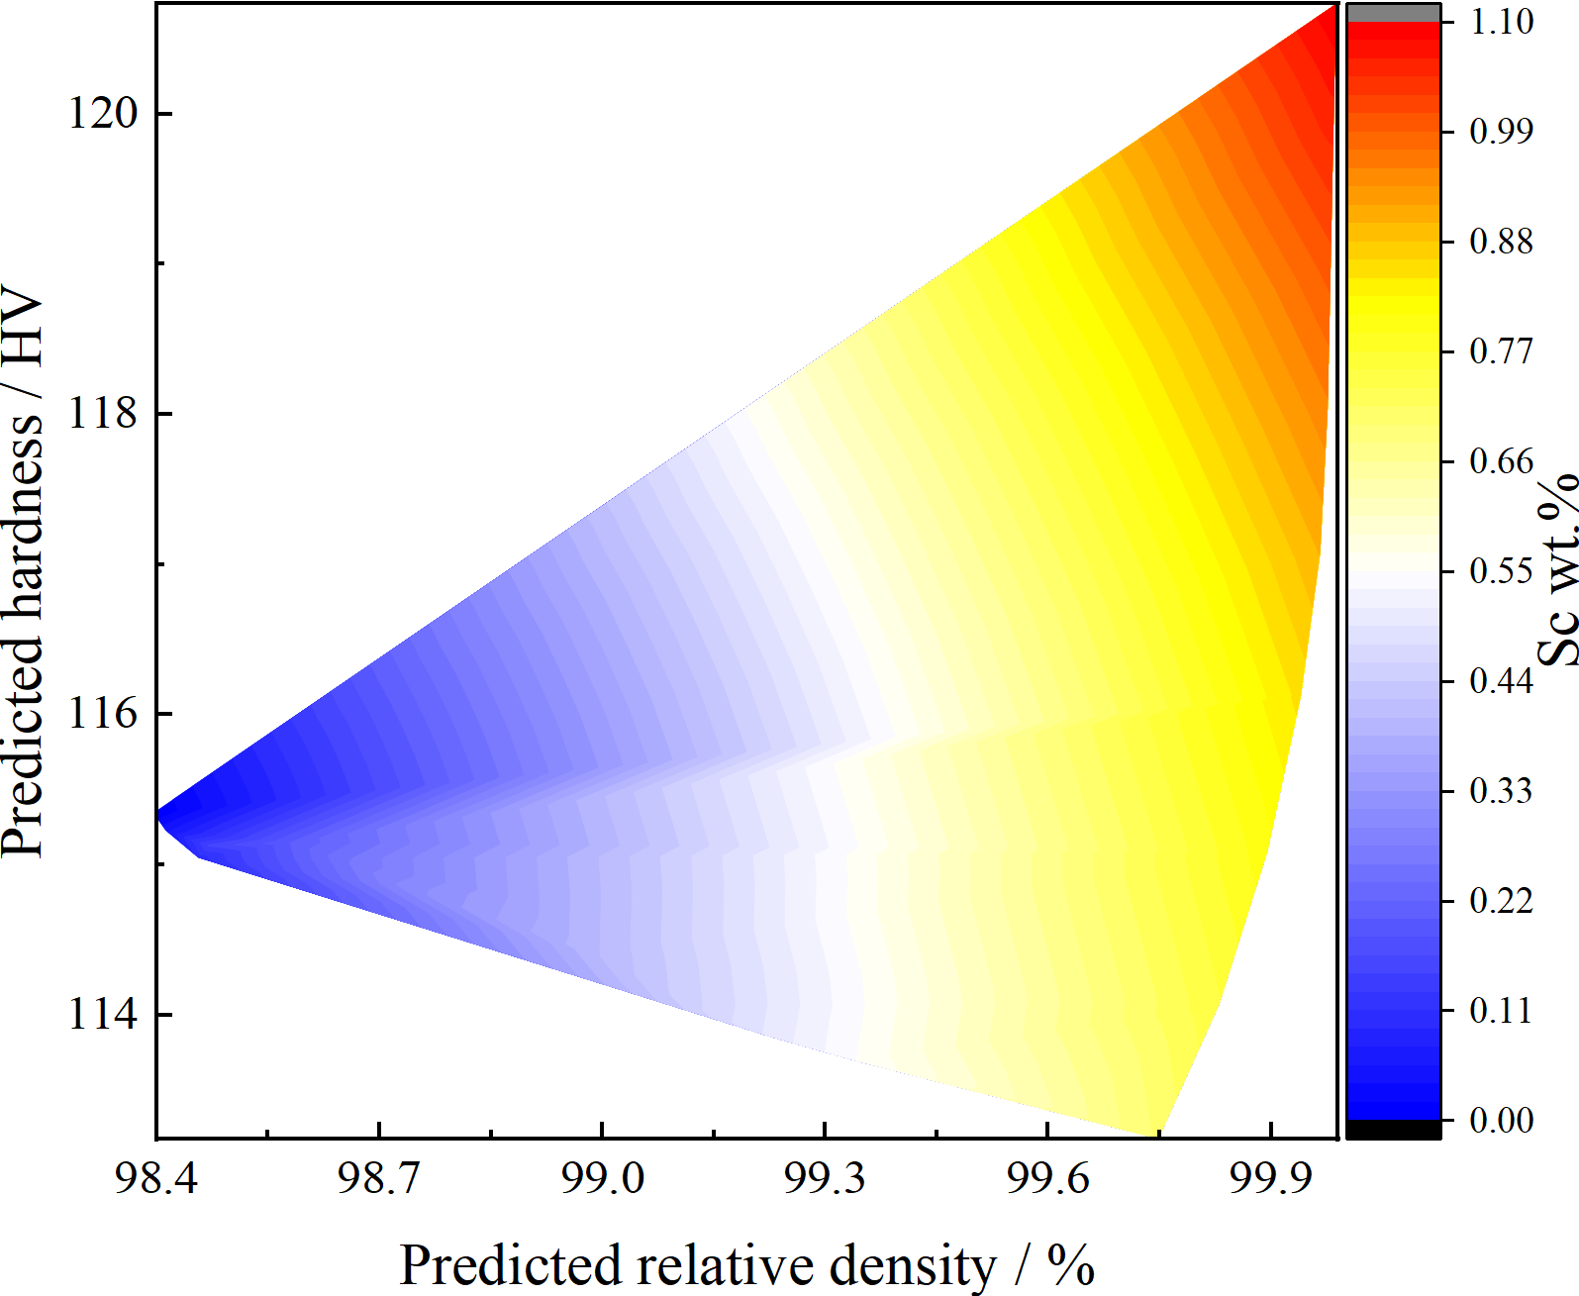

Fig. S9. The predicted relative density and hardness with increasing Sc content.

While elevated Sc content serves as an effective indicator for achieving enhanced strength and printability in alloy design, the industrial cost concerns associated with excessive Sc addition. To address this practical limitation, the relationship between Sc content reduction and its impact on printability and mechanical properties are further evaluated. As illustrated in Fig. S9, our multi-objective optimization framework identifies multiple feasible compositions with varying Sc concentrations. Notably, when Sc content exceeds 0.8 wt.%, the predicted relative density and hardness remain stable within an optimal range, demonstrating a clear trade-off boundary between material performance and manufacturing cost. This finding provides actionable guidance for future research to balance cost-effectiveness and material performance through Sc content optimization, ensuring industrial applicability without compromising essential mechanical performance.

**Reference**

[1] J.H. Martin, B.D. Yahata, J.M. Hundley, J.A. Mayer, T.A. Schaedler, T.M. Pollock, 3D printing of high-strength aluminium alloys, Nature 549(7672) (2017) 365-369.

[2] T. DebRoy, H.L. Wei, J.S. Zuback, T. Mukherjee, J.W. Elmer, J.O. Milewski, A.M. Beese, A. Wilson-Heid, A. De, W. Zhang, Additive manufacturing of metallic components – Process, structure and properties, Progress in Materials Science 92 (2018) 112-224.

[3] B. Mondal, T. Mukherjee, T. DebRoy, Crack free metal printing using physics informed machine learning, Acta Mater. 226 (2022) 117612.

[4] H.L. Wei, J.W. Elmer, T. DebRoy, Three-dimensional modeling of grain structure evolution during welding of an aluminum alloy, Acta Mater. 126 (2017) 413-425.

[5] T. Mukherjee, H.L. Wei, A. De, T. DebRoy, Heat and fluid flow in additive manufacturing – Part II: Powder bed fusion of stainless steel, and titanium, nickel and aluminum base alloys, Comput. Mater. Sci. 150 (2018) 369-380.

[6] T. Mukherjee, H.L. Wei, A. De, T. DebRoy, Heat and fluid flow in additive manufacturing—Part I: Modeling of powder bed fusion, Comput. Mater. Sci. 150 (2018) 304-313.

[7] M. Collur, A. Paul, T.J.M.T.B. DebRoy, Mechanism of alloying element vaporization during laser welding, 18 (1987) 733-740.

[8] F. Wirth, K. Wegener, A physical modeling and predictive simulation of the laser cladding process, Addit. Manuf. 22 (2018) 307-319.

[9] V.R. Voller, C.R. Swaminathan, Eral Source-Based Method for Solidification Phase Change, Numerical Heat Transfer, Part B: Fundamentals 19(2) (1991) 175-189.

[10] P. Velickovic, G. Cucurull, A. Casanova, A. Romero, P. Lio, Y. Bengio, Graph attention networks, International Conference on Learning Representations, 2017, pp. 1-12.

[11] K. Xu, W. Hu, J. Leskovec, S.J.a.p.a. Jegelka, How powerful are graph neural networks?, International Conference on Learning Representations, 2019, pp. 1-17.

[12] S. Zhu, Y. Zhang, B. Zhu, J. Zhang, Y. He, W. Xu, High cycle fatigue life prediction of titanium alloys based on a novel deep learning approach, Int. J. Fatigue 182 (2024) 108206.

[13] C. Wang, K. Zhu, P. Hedström, Y. Li, W. Xu, A generic and extensible model for the martensite start temperature incorporating thermodynamic data mining and deep learning framework, J. Mater. Sci. Technol. 128 (2022) 31-43.

[14] X. Wei, S. van der Zwaag, Z. Jia, C. Wang, W. Xu, On the use of transfer modeling to design new steels with excellent rotating bending fatigue resistance even in the case of very small calibration datasets, Acta Mater. 235 (2022) 118103.

[15] O. Gharbi, D. Jiang, D.R. Feenstra, S.K. Kairy, Y. Wu, C.R. Hutchinson, N. Birbilis, On the corrosion of additively manufactured aluminium alloy AA2024 prepared by selective laser melting, Corros. Sci. 143 (2018) 93-106.

[16] M.A. Pekok, R. Setchi, M. Ryan, Q. Han, D. Gu, Effect of process parameters on the microstructure and mechanical properties of AA2024 fabricated using selective laser melting, Int. J. Adv. Manuf. Technol. 112(1-2) (2020) 175-192.

[17] M.M.Z. Ahmed, M.M. El-Sayed Seleman, E. Elfishawy, B. Alzahrani, K. Touileb, M.I.A. Habba, The Effect of Temper Condition and Feeding Speed on the Additive Manufacturing of AA2011 Parts Using Friction Stir Deposition, Materials 14(21) (2021).

[18] V. Gopan, V. Vijayan, R. Surjith Unnikrishnan, A. Akash, P.K. Ashwanth, Investigating the effects of different particulate deposition techniques on the fabrication of AA 2014/TiC surface composites using friction stir processing, Mater. Today Proc. 72 (2023) 3116-3120.

[19] R. Li, R. Wang, X. Zhou, Z. Yan, J. Huang, C. Ma, Y. Liu, H. Zhang, R. Ji, Microstructure and mechanical properties of 2319 aluminum alloy deposited by laser and cold metal transfer hybrid additive manufacturing, J. Mater. Res. Technol. 26 (2023) 6342-6355.

[20] H. Hassanpour, R. Jamaati, S.J. Hosseinipour, A novel technique to form gradient microstructure in AA5052 alloy, Mater. Sci. Eng. A. 777 (2020) 139075.

[21] L. Tan, T.R. Allen, Effect of thermomechanical treatment on the corrosion of AA5083, Corros. Sci. 52(2) (2010) 548-554.

[22] H. Jin, D.J.M. Lloyd, M.T. A, The tensile response of a fine-grained AA5754 alloy produced by asymmetric rolling and annealing, 35 (2004) 997-1006.

[23] O. Engler, Texture and anisotropy in the Al–Mg alloy AA 5005 – Part I: Texture evolution during rolling and recrystallization, Mater. Sci. Eng. A. 618 (2014) 654-662.

[24] A. Mehta, L. Zhou, T. Huynh, S. Park, H. Hyer, S. Song, Y. Bai, D.D. Imholte, N.E. Woolstenhulme, D.M. Wachs, Y. Sohn, Additive manufacturing and mechanical properties of the dense and crack free Zr-modified aluminum alloy 6061 fabricated by the laser-powder bed fusion, Addit. Manuf. 41 (2021) 101966.

[25] F. Li, T. Zhang, Y. Wu, C. Chen, K. Zhou, Microstructure, mechanical properties, and crack formation of aluminum alloy 6063 produced via laser powder bed fusion, J Mater Sci 57(21) (2022) 9631-9645.

[26] J. Blindheim, Ø. Grong, T. Welo, M. Steinert, On the mechanical integrity of AA6082 3D structures deposited by hybrid metal extrusion & bonding additive manufacturing, J. Mater. Process. Technol. 282 (2020) 116684.

[27] O.R. Myhr, Ø. Grong, C. Schäfer, An Extended Age-Hardening Model for Al-Mg-Si Alloys Incorporating the Room-Temperature Storage and Cold Deformation Process Stages, Metall. Mater. Trans. A 46(12) (2015) 6018-6039.

[28] V.K. Beura, A. Sharma, Y. Karanth, S. Sharma, K. Solanki, Corrosion behavior of 7050 and 7075 aluminum alloys processed by reactive additive manufacturing, Electrochim. Acta 470 (2023).

[29] X.J. Wang, L.C. Zhang, M.H. Fang, T.B. Sercombe, The effect of atmosphere on the structure and properties of a selective laser melted Al–12Si alloy, Mater. Sci. Eng. A. 597 (2014) 370-375.

[30] J. Praneeth, S. Venkatesh, L. Sivarama Krishna, Process parameters influence on mechanical properties of AlSi10Mg by SLM, Mater. Today Proc. (2023).

[31] H. Tang, Y. Geng, J. Luo, J. Xu, H. Ju, L. Yu, Mechanical Properties of High Mg-Content Al-Mg-Sc-Zr Alloy Fabricated by Selective Laser Melting, Met Mater Int 27(8) (2021) 2592-2599.

[32] Y. Shi, K. Yang, S.K. Kairy, F. Palm, X. Wu, P.A. Rometsch, Effect of platform temperature on the porosity, microstructure and mechanical properties of an Al–Mg–Sc–Zr alloy fabricated by selective laser melting, Mater. Sci. Eng. A. 732 (2018) 41-52.

[33] Y. Shi, P. Rometsch, K. Yang, F. Palm, X. Wu, Characterisation of a novel Sc and Zr modified Al–Mg alloy fabricated by selective laser melting, Mater. Lett. 196 (2017) 347-350.

[34] F. Yang, J. Wang, T. Wen, L. Zhang, X. Dong, D. Qiu, H. Yang, S. Ji, Developing a novel high-strength Al–Mg–Zn–Si alloy for laser powder bed fusion, Mater. Sci. Eng. A. 851 (2022) 143636.

[35] L. Li, R. Li, T. Yuan, C. Chen, Z. Zhang, X. Li, Microstructures and tensile properties of a selective laser melted Al–Zn–Mg–Cu (Al7075) alloy by Si and Zr microalloying, Mater. Sci. Eng. A. 787 (2020) 139492.

[36] S. Deng, L. Wang, H. Zhao, J. Shao, J. Li, O.A. Ojo, L. Zhang, R. Li, L. Xu, Microstructure and mechanical properties of selective laser melted Al-Zn-Mg-Si-Sc-Zr alloy with high hot-cracking resistance, J. Alloy. Compd. 973 (2024) 172930.

[37] H. Hyer, L. Zhou, S. Park, T. Huynh, A. Mehta, S. Thapliyal, R.S. Mishra, Y. Sohn, Elimination of extraordinarily high cracking susceptibility of aluminum alloy fabricated by laser powder bed fusion, J. Mater. Sci. Technol. 103 (2022) 50-58.

[38] Y. Huang, P. Sun, L. Sun, Y. Li, X. Zheng, X. Li, H. Yan, B. Li, Y. Liu, Y. Du, Effect of Zn/Mg ratio on aging precipitates and mechanical property of high Mg content Al-Mg-Zn alloys with Sc and Zr additions, J. Alloy. Compd. 976 (2024) 173368.

[39] Y. Zhao, T. Tian, H. Jia, P. Ma, Z. Yang, J. Xu, M. Zha, H. Wang, Effects of Mg/Zn ratio and pre-aging on microstructure and mechanical properties of Al–Mg–Zn–Cu alloys, J. Mater. Res. Technol. 27 (2023) 1874-1885.